Input Data :-

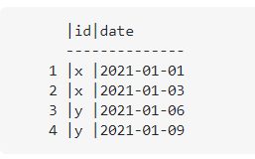

Output data using (**GENERATE_DATE_ARRAY** Function):-

